1. 
2. **CountDownLatch** can be seen as a variable on top of which a thread will wait for it to become zero.
3. The value for CountDownLatch is the no of sub-tasks for which the main thread would wait for their tasks to be completed.
4. 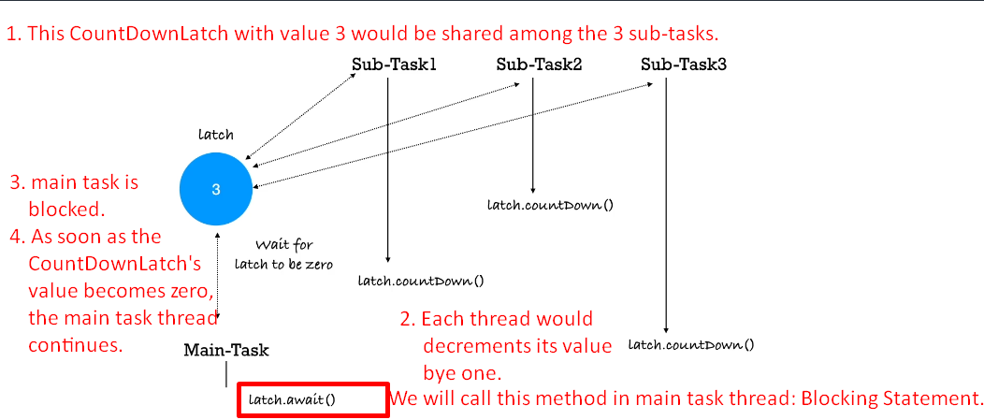
5. 